FROM :

DATE :

SUBJECT :

Good day!

This is to formally notify you that the indicated employee has tendered her resignation, effective as of the date mentioned below:

NAME OF EMPLOYEE | POSITION | DEPARTMENT | DATE  SUBMITTED | LAST DAY OF SERVICE

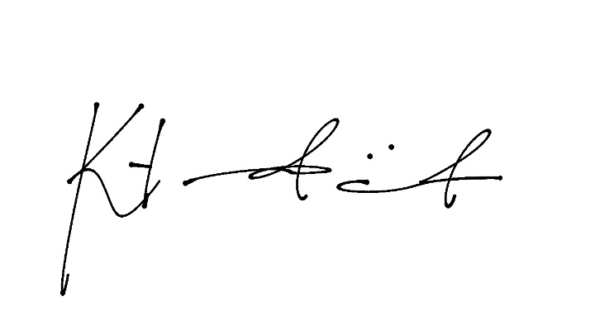
Should you require any further details or clarification, please feel free to contact the HR Department.

Thank you for your prompt attention to this matter.

Katrina Pauline M. Trinidad

HR Officer II

Human Resources Department

Sadsad Tamesis Legal and Accountancy Firm

7F, Victoria Sports Tower EDSA, South Triangle, Quezon City

